THE ROAD NOT TAKEN…? (apologies to Robert Frost)

I've had a number of emails with people concerned that the road repairs and some other local roads appear unfinished. They have certainly been left uneven and unsightly as in the photo below.

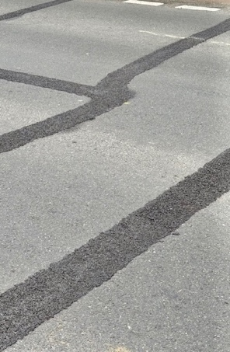
I hope I can reassure you that this is only the first part of work to resurface the roads in questions.

The uneven surface is as a result of ‘crack sealing’, which is undertaken to seal any cracks identified in the road, most particularly along the joins of previous utility repairs.

This is preparatory work for resurfacing of the road, the principle being that by sealing the cracks in the current surface then once the new surface is laid then it makes it less likely that there is damage to the undersurface of the road due to water ingress or movement during cold weather. This therefore reduces the likelihood of potholes forming in the new surface and thereby elongates the life of the road surface.

Greater powers to tackle fly-tipping

I strongly welcome the Government's announcement of a new crackdown on cowboy waste operators to tackle fly-tipping and clean up our streets, lanes, and rural areas.

Key Points:

- Councils will work with the police to identify, seize, and crush vehicles of waste criminals.

- Drones and mobile CCTV cameras will be used to identify and destroy cars and vans belonging to fly-tippers.

- A rapid review will slash red tape, allowing councils to seize and crush vehicles more easily. Fly-tippers will cover the costs, saving money for councils and taxpayers.

- Waste criminals will now face up to five years in prison for illegal operations.

- The Environment Agency will conduct identity and criminal record checks on operators, with increased resources and powers to revoke permits, issue enforcement notices, and impose hefty fines.

As you know, Hampshire councils have for many years been at the forefront of the fight against fly tipping. I really hope these new powers are brought in quickly and are used by all local authorities to tackle the criminals who blight our beautiful county with their selfish, greedy and thoughtless behaviour.

Myths about animals in Hampshire’s countryside

The British countryside is steeped in centuries of myth, superstition, and storytelling — and we’re here to share some of the most fascinating traditions with you!

From bees to butterflies, mice to rabbits, each creature was once believed to carry hidden meanings, omens, and even magical powers.

 Mice: If mice invaded your home, it was seen as a bad omen, a warning of illness or even death. But don't worry — folklore offers a humane solution! Simply ask the mice politely to leave, explaining that your home is not convenient for them.

 Eels: It was once believed you could create an eel by tossing horsehair into a running stream! Eels were thought to cure deafness and rheumatism, though many people were wary of eating them.

 Bees: Bees were considered sacred and wise. Tradition says you must always speak kindly around bees, inform them of major family events like weddings or funerals, and even feed them cake from these celebrations to keep them happy and loyal.

 Rabbits: The rabbit’s foot — especially the left hind leg — was a symbol of good luck, tracing back to Celtic beliefs. Rabbits were seen as messengers between our world and the spirit realm. (Just to be clear, we don’t recommend collecting rabbit feet today!)

 Butterflies: Superstitions say that a white butterfly in your home brings good luck, a brown butterfly brings important news, and a yellow one promises sunny days ahead. Some even believed butterflies were the souls of loved ones visiting from beyond.

The countryside isn’t just beautiful — it’s alive with ancient stories.

Want to know more? Hampshire's Countryside Service has more detail in their blog and podcast you can find here: https://www.hants.gov.uk/.../countryside/blog/202410-myths

Getting ready for a spring clean?

Don't be tempted to engage with people on social media who offer to remove your waste, unless they are licensed waste carriers.

It is your duty of care to dispose of your waste correctly. You could be fined an unlimited amount if your waste ends up fly-tipped.

Check your waste carrier is licensed here: http://bit.ly/2Hn8ygE

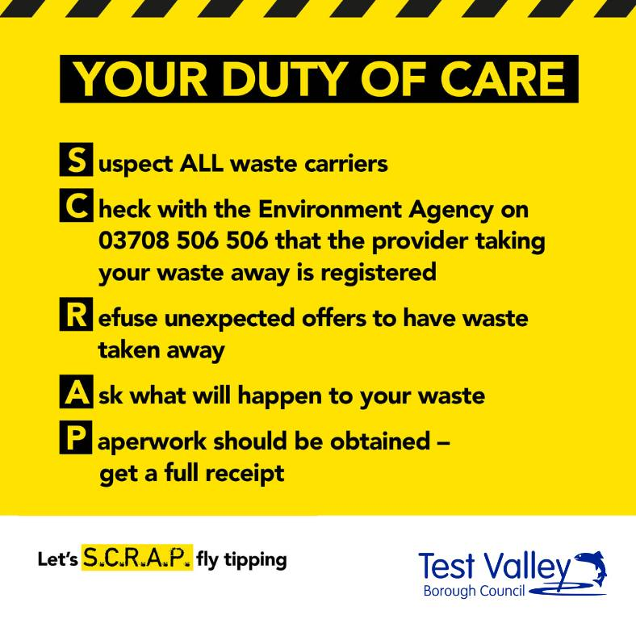

General HCC Information

Deadline reminder for SEN parents applying for School Transport
Hampshire parents who would like their SEN children to be considered for School Transport from September 2025 must apply on time to make sure their applications are reviewed before the new school year starts. The deadline is 30th June.
Deadline reminder for parents applying for School Transport | Hampshire County Council

Primary school place offers confirmed by Hampshire County Council
Primary school place offers confirmed by Hampshire County Council | Hampshire County Council

Hampshire County Council set to consider proposals to boost recycling rates
Proposals that would boost recycling rates in Hampshire are due to be considered later this month by Hampshire County Council. The plans, if approved, would deliver a state-of-the-art Materials Recovery Facility that could process more types of household waste for recycling.
Hampshire County Council set to consider proposals to boost recycling rates | Hampshire County Council

Green light to boosting recycling rates in Hampshire
Plans to construct of a new, state of the art recycling facility for Hampshire, have been given the go-ahead enabling residents to recycle a wider range of household materials at the kerbside in future.
Green light to boosting recycling rates in Hampshire | Hampshire County Council

Any questions on these or any other county council issues please email me and I will take action.

* * *

Councillor Jonathan K. Glen
HCC Member for Odiham, Hook & The Western Parishes
jonathan.glen@hants.gov.uk

